Mariachi Music Class

Business Plan

Juan José Magaña-Paredes

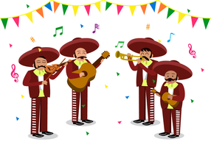

BUS 18A

Professor Hudena, James

Tuesday, Thursday 08:00 AM- 09:25 AM

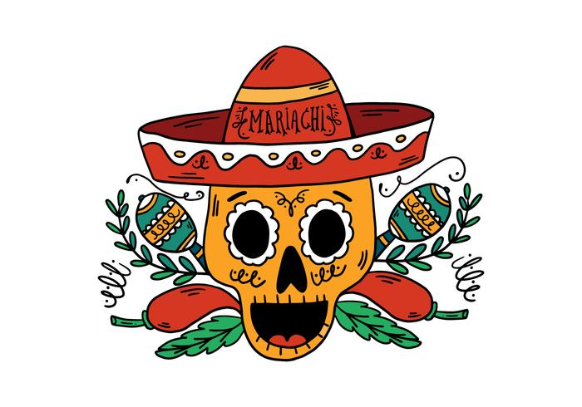

# Table of Contents

1. Table of Contents
2. Introduction: Request for Funding
3. Personal Experience & Background
4. Resume
5. Business Description
6. Marketing Plan
7. Financial Projection
8. Personal Finance Statement
9. Business Risk Analysis
10. Capital Spending Plan
11. Personal Goals to Achieve This Business

Introduction

I am interested in investing my knowledge and time to teach music classes of the mariachi genre to any child or adult interested in learning how to play an instrument involved with the genre or anyone interested in learning about the play style.

I will be requesting funds to start giving classes located at a venue in the middle of town near a shopping center plaza. I will need about $50,000 to be able to pay for necessary equipment and expenses needed to proficiently run my business.

The necessary equipment will include, but not limit to, instruments, instrumental accessories, musical resources, promotional propaganda, office supplies, and complementary water for the guests and customers. For the instruments I will require to attain at least one piano, four trumpets, four violins, four guitars, four vihuelas, four guitarron, four keyboards, and one harp. For the instrumental accessories and musical resources I will require to attain at least twelve music stands, sheet music for the appropriate instrument, strings for the proper instruments, and cases for the proper instruments. For the promotional propaganda I will need to acquire business cards, flyers, and a banner. As for the office supplies, I will need to acquire a receipt book, a desk, promotional pens, a file cabinet and a water dispenser with cups.

The other expenses I will require are for paying the first year lease on the studio I would like to be located in and for any necessary renovations.

My goal is to not only teach music but to also give my students a cultural glimpse into the background of mariachi music and help the Latin culture flourish in my community.

Experience & Background

As of 2019, I have had eighteen years of musical experience. I am self-taught, but I did attend countless hours worth of classes and workshops to gain proper and newfound knowledge of music theory, music appreciation, and abilities to play many instruments. Aside from gaining vast musical knowledge for personal gain, I attended seminars and workshops to teach music to children and any other person interested in learning about music and music playing.

My first instrument was the guitar. I taught myself all the basic fundamentals on playing the guitar via books I would research at my local library and via the internet, alongside with YouTube. After I mastered as much as I could on my own, I tested my skills with a music teacher where it was then that I was instructed certain exercises to properly play the guitar. My teacher told me that I was very advanced for a beginner and I did not need much tutoring to master the guitar. After I did just that, I moved on to other instruments like the piano, bass, drums, cello, trumpet, accordion, vihuela, guitarron, harp, violin, and many more.

I have performed in various bands and groups of varying musical genres. I have played in many parties, banquets, quinceñeras, schools, and recreational festivals and events. I have had the opportunity to perform at Disneyland California Adventures. In my most recent musical group, I was the lead guitarist in a mariachi group that originated as a school club for Moreno Valley Community College.

 Resume

**Juan José**

**Magaña-Paredes**

12345 Brockton Ave. Apt. 69

Moreno Valley, CA 99366

(420) 420-6969

Music_Teacher@gmail.com

| **SKILLS** | **Languages**   * English * Spanish   **Sales**   * Communication skills * People skills   **Leadership**   * Instructor, Mariachi Classes   **Additional Musical Instrument** **Skills**   * Guitar * Violin * Cello * Trumpet * Piano * Vocals * Bass * Percusion |
| --- | --- |
| **EXPERIENCE** | **Mariachi Instructor** (part-time), Mariachi Classes, 23655 Sunnymead Boulevard suite A, Moreno Valley, CA 99366, (975) 323-4587  July 2018 to present  **Musician** (full-time), Disney Cruise Line, 130 W Walnut Ave A-12, Celebration, FL 92571, (951) 943-2898  July 2016 to June 2018  **Sales Associate** (part-time), Guitar Center, 2550 Canyon Springs Pkwy Suite A, Riverside, CA 92507, (951) 413-2951  May 2012 to June 2016 |
| **EDUCATION** | **Moreno Valley Community College** Music major  February 2013 to present  **Riverside City Community College** Computer Science major, Automotive minor  February 2014 to present  **Graduate of Moreno Valley High School**  June 2012 |

Business Description

The title of my business will be “Mariachi Music Studio” and will operate Monday through Friday from 8 a.m. to 5 p.m. and will be closed on holidays. The studio will be located at a venue in the middle of town near a shopping center plaza. Inside the studio I will have a waiting room as soon as you step into the door. Here I will have the room feel like an inviting “living-room-like” space where I will have a small stage in one corner, furniture to sit on in the middle of the room and an information desk and water dispenser for complimentary water to my guests and alumni in the opposite corner of the stage. From this room I will have hallways that would lead to multiple rooms where the lessons will be held for private lessons.

Each lesson will be based on a timely set booking basis. Each lesson can either run for thirty minutes, forty-five minutes, or sixty minutes. The price for each class session will be twenty dollars, thirty dollars, and forty dollars respectively to the lengths of the class. The instruments that will be taught will be the guitar, guitarron, vihuela, violin, trumpet, harp, and voice. The curriculum will consist of learning the anatomy of the chosen instrument of the student’s choice, music theory to enhance the students ability to play notes, chords, and songs, and it will also include vocal control and technique for those interested in singing, all with emphasis to the mariachi genre. I will also establish a master class for those interested in forming a mariachi ensemble.

The lessons will be taught by me and other teachers with music degrees and/or musical backgrounds with a formal proficiency. Classes will be for ages five and up.

Marketing Plan

I am going to have multiple forms of promoting my business brand along with different forms of partnerships and special price packages.

| **Billboard:** | I will rent out billboard space by the freeway that exits a mile away into the plaza where my studio will be located |
| --- | --- |
| **Business Cards:** | I will print out about 2,000 cards to start with. Each card will have the address of the studio, hours of operation, the business email, the business phone number, the name of the business, and a yearly calendar on the back. |
| **Partnership:** | I will partner with local food places located in the same plaza to promote my business and dispene business cards and vice versa. I will target the latin cuisine locations because of the mariachi genre relating heavily to latin culture. |
| **Social Media:** | I will promote the music lessons through Facebook, Instagram, Snapchat, and Twitter. |
| **Promotional Pricing Packages:** | **Monthly Price:** For the respective time length chosen for lessons by the client, I will give them a 15% discount to what would be the total price of the month.  **Group Private Lessons:** The initial student will pay full price where the third and onward will pay half of the initial student price. |

Financial Projection

| **Mariachi Music Studio**  **Projected Income Statement**  **Launch of Studio Operation**  **Month of January, 2019** | |
| --- | --- |
| **Revenues:**  **Cost of Goods Sold:**  **Gross Profit:**  **Operating Expenses:**  **Marketing Expenses**  **Office Supply Expenses**  **Rent**  **Musical Instrument Expenses**  **Total Operating Expenses:** | $30,000  (1,000)  **$29,000**  12,000  1,000  2,500  3,000  **$18,500** |
| **Net Income:** | **$10,500** |

Personal Finance Statement

| **Personal Finance Statement**  **Month of January, 2019** | |
| --- | --- |
| **Assets:**  **Checking Account**  **Savings Account**  **Retirement Funds**  **Real Estate**  **401K**  **Total Assets**  **Liabilities:**  **Real Estate Debt**  **Credit Card Debt**  **Car Payment Debt**  **Miscellaneous Debt**  **Total Debt:** | $5,420.69  15,000.00  80,000.00  105,000.00  69,000.00  **$274,420.69**  12,000  1,000  2,500  3,000  **$18,500** |
| **Net Worth:** | **$255,920.69** |

 Business Risk Analysis

As a starting business I am aware of the possible risks that can occur during my time of operation. Listed below are some of the several possibilities that can occur while I run my business of music lessons.

**Music Business is competitive/risky**

I will only run one of many already built establishments that give music lessons to the community. I will have to compete with their prices. Also I will have no guarantee that even if I have a better quality in my way of teaching as opposed to my competitors, if the client seeking musical assistance prefers a cheaper experience, it is up to the customer to decide where they want to do business.

**Not enough students**

Similar to the topic about pricing in the previous risk, a major factor in my business will be to have students. If I have no students, I have no one to teach. A factor to not having enough students, or any at all, would be the economy of my current location. Another factor would just simply be a disinterest in learning mariachi music. The client may want to learn how to play an instrument of the variety that I would give lessons to but they may not like the mariachi genre and would want to do jazz or rock or any other genre. If I have no students, I will also have no means of making profit.

**Theft**

There is the possibility of theft due to the expensive equipment that I will be storing in the studio.

 Capital Spending Plan

| **Fixed Cost:**  **Land (Rent)**  **Insurance (monthly)**  **Water (monthly)**  **Electricity (monthly)** | $2,500  5,000  100  100 |
| --- | --- |
| **Total Fixed Cost:** | **$7,700** |

| **Variable Cost:**  **Guitar (each)**  **Violin (each)**  **Guitarron (each)**  **Vihuela (each)**  **Trumpet (each)**  **Keyboard (each)**  **Harp**  **Grand Piano**  **Office Supplies**  **Furniture**  **Music Stands (each)**  **Decorations**  **Soundproof Foam**  **(a piece)**  **Salaries**  **(commission per student)**  **[30 minutes]**  **[45 minutes]**  **[60 minutes]** | $150  80  200  100  75  250  275  300  550  350  10  255  35  10  15  20 |
| --- | --- |
| **Total Variable Cost:** | **$2,675** |

Personal Goals to Achieve ThisBusiness

My personal goals for this business are to be able to expand the latin culture of Mexico to my community by the means of mariachi music. Many of the youth that are of latin descent fall away from their latin roots. I believe that through music, they can connect back to their ancestral backgrounds. By playing the music that their parents or grandparents would listen to, they can connect and share stories of their past memories that connect to the times they would listen to such songs.

I also wish to better enhance the local kids minds and abilities. I want to help the youth in my community to stay out of the streets and have something productive to do that is also educational but fun. I believe that if a child or teenager takes up music, they are able to think better and will enhance their abilities in their studies and athletic activities. Music has a very impacting effect on both halves of our brains which can fuel our senses of imagination and logic. Performing what the students will learn while attending my studio, the shy students will be able to break out of their shells and become confident future citizens of our society.

Overall I want to help my younger clients to do better in school and to connect to their ancestral roots. For my older clients, I would like to have them connect to the youth and blur the line between a generational gap. I want to pass on my knowledge so that at least one of my students can be able to continue my love for connecting society through music.